EU Declaration of Conformity
Annex IX PPE Regulation (EU) 2016/425

This EU Declaration of conformity refers to the following products:
Product name | Model | Classification | Batch No.
Particle filtering half mask | JFM05 | FFP2 NR

The Manufacturer’s name and address is as follows:
Name | Jifa Group Co., Ltd.
Address | Jiangnan Development Area, Dongyang City, Zhejiang Province, P. R. China

This Declaration of Conformity is issued under the sole responsibility of the Manufacturer.
Detailed description of the PPE to allow traceability/identification of the PPE.
White folding half mask without valve
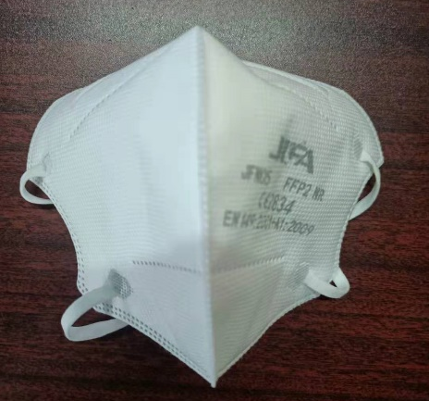 | 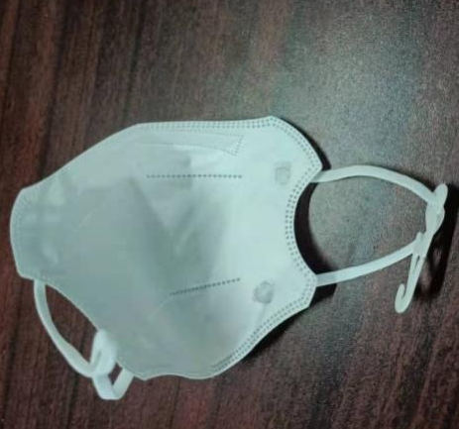 | 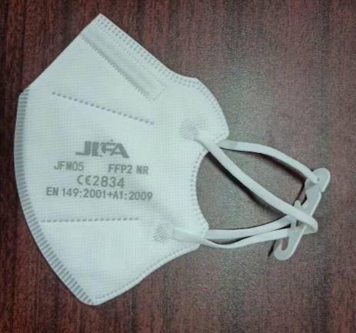
blue folding half mask without valve
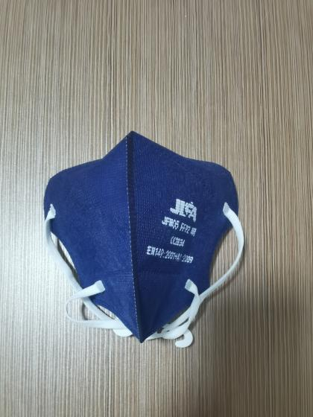 | 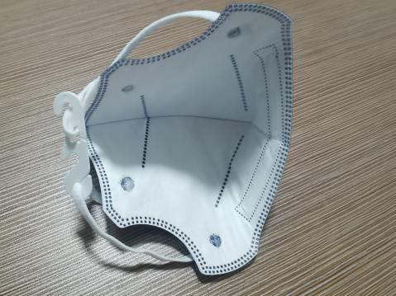 | 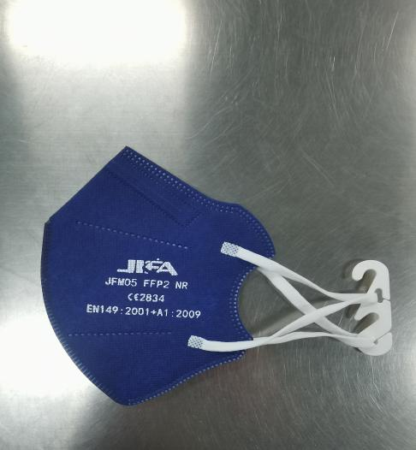
green folding half mask without valve
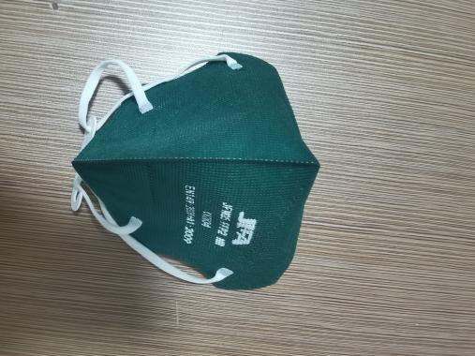 | 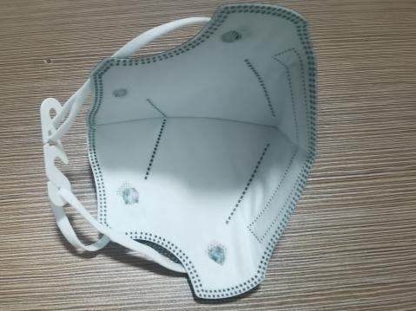 | 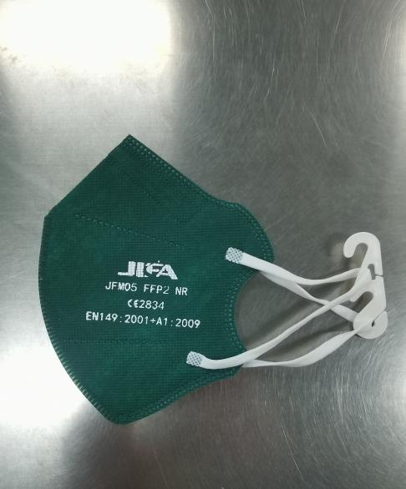
black folding half mask without valve
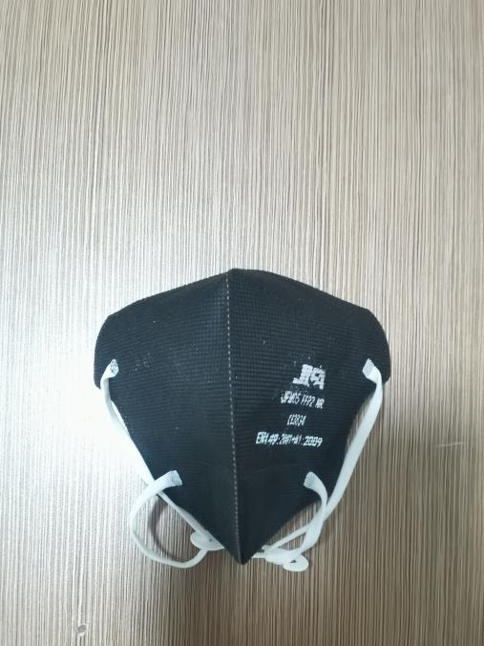 | 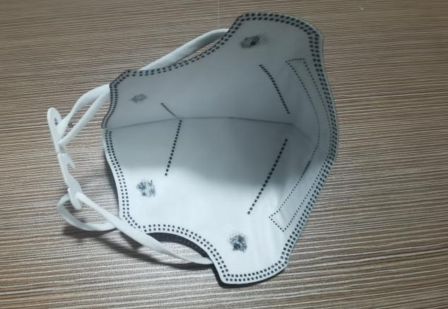 | 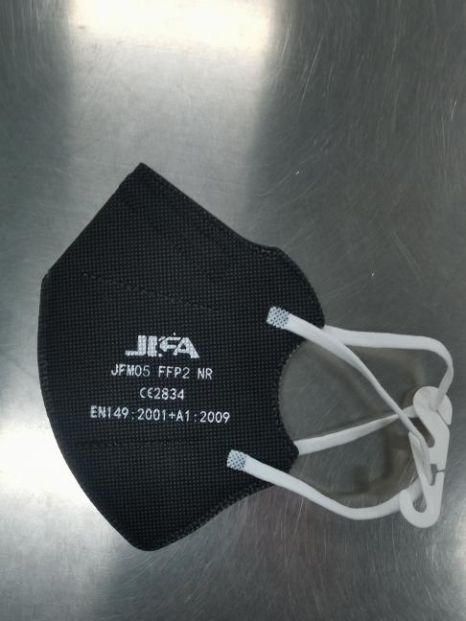
Pink folding half mask without valve
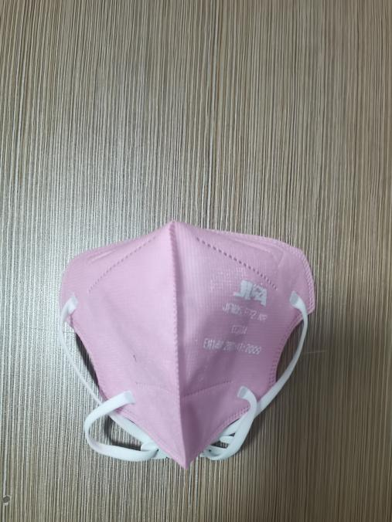 | 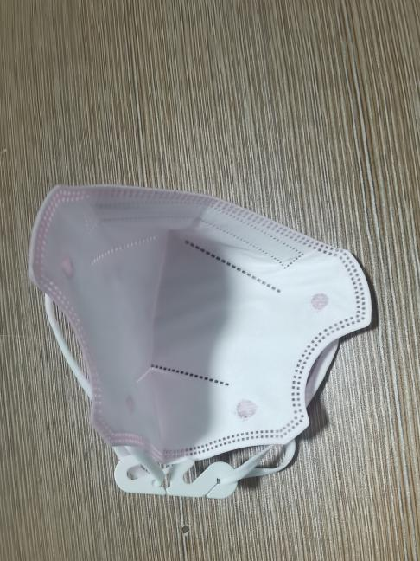 | 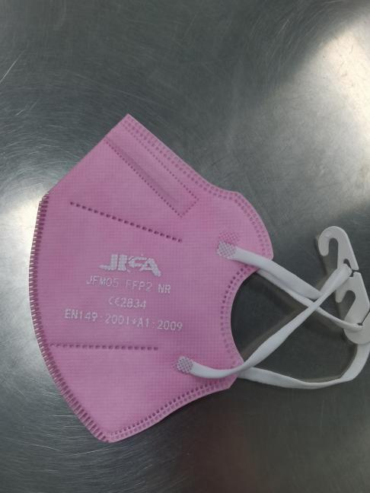

The article identified in product category is in conformance with the relevant Union Harmonization Legislation Regulation (EU) 2016/425. References to the relevant harmonized standards used, including the date of the standard, or references to the other technical specifications, including the date of the specification, in relation
to which conformity is declared: EN 149:2001+A1:2009.

CCQS Certification Services Limited. (NB 2834) performed the EU Type Examination (Module B) and issued the Type Examination Certificate as follows:
No. | EU Type Examination (Module B) Certificate Number
1 | CE-PC-210324-154-01-9B

Product Category:
This product is Category III and is subject to Module C2 internal production control plus supervised product checks at random intervals and is under the surveillance of CCQS Certification Services Limited. (NB 2834)

Signature: _______________ Date: _____________ Company stamp: _______________

